 COMSATS University Islamabad, Lahore

FALL 2020
□ Sessional-1 □ Sessional-II □ Terminal Examination
Course Title: | Semantic Web (Theory) |  |  |  | Course Code: |  | CSE344 | Credit Hours: | 3(2,1)
Course Instructor/s: | Sana Rizwan |  |  |  | Program Name: |  | BSSE
Semester: | 7th | Batch: | FA17 | Section: | A |  | Date:
Time Allowed: | 1 Hour 15 minutes |  |  |  | Maximum Marks: |  |  | 40
Student’s Name: |  |  |  |  | Reg. No.
Important Instructions / Guidelines:
- Rewriting and cuttings are not allowed. All questions are compulsory.

Question 1: (Marks = 20)

Solve Multiple Choice Questions:

1. In RDF schema, variable names start with,
- !
- #
- ?
- @
2. In RDFS to use core class of all strings, the element used is
- rdfs:Literal
- rdfs:Class
- rdfs:Resource
- rdf:Statement
3. In RDFS to use core property of relationship among class and its superclass, the element used is
- rdfs:subClassOf
- rdfs:Class
- rdfs:subPropertyOf
- rdf:Property
4. RDF uses logical formula in
- Semantic Web
- Graph view
- XML view
- Definition view
5. In container element, the pre-defined type used for referencing other than first element of list is
- rdf:rest
- rdf:first
- rdf:List
- rdf:nil
6. In RDF Schema, the functional symbol returns true if a is a list is
- list(a)
- item(y,a)
- rest(a)
- first(a)
7. In RDF Schema, the functional symbol for returning the rest of the list is
- rest(a)
- first(a)
- cons(y,a)
- nil
8. __________ is framework for viewing, manipulating, and associating networked collections of distributed information.
- GRDDL
- RDFa
- RFDFS
- RDF
9. Edges and vertices are labeled with URIs. It has blank node identifier.
- Multi graph
- Directed graph
- Labeled graph
- Bi-directional graph
10. Resources described by RDF using tags ____________________.
- rdfs:Datatype
- rdfs:Resource
- rdfs:Class
- rdfs:Literal
11. _______________is an instance of rdf property that may be used to provide a human-readable description of a resource.
- rdfs:Resource
- rdfs:range
- rdfs:domain
- rdfs:comment
12. rdf:rest is an instance of rdf property that can be used to build descriptions of lists and other list-like structures.
- rdf:nil
- rdf:resource
- rdf:first
- rdf:rest
13. Triple (http://abc.html, dc:creator,_:abc), has _:abc, what does it means?
- Literal
- Blank nodes
- Namespace
- Unknown nodes
14. There are ____ ways of triple serialization in RDF.
- 1
- 4
- 2
- 3
15. If we want to replace rdf:li with some appropriate property in sequence, select the particular one.

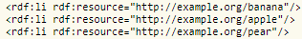
- rdf:_last
- rdf:_front
- rdf:_1, rdf:_2, rdf:_3
- rdf:nil
16. In Rdfa use of Property tag is

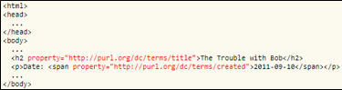
- Add another resource
- Add another property
- Add another element
- Add another vocabulary
17. RDFa tag will be written in
- <HTML>
- <Title>
- <Body>
- <Head>
18. RDFa is perfectly well prepared to handle several vocabularies within one file. This is because RDFa is based on the usage of URIs, meaning that usage of various terms can be interleaved without any problems.
- True
- False
19. GRDDL processor execute each transformation collectively and perform an RDF merge on the generated graphs, yielding the result.
- True
- False
20. Which microformat will use to add details of student’s first_name, Last_name, address, Tel no. and CNIC no. etc.
- hCalender
- vCalender
- hCard
- vCard

Question 2: (Marks = 20)

Solve Short Questions:
Part 1: (Marks = 4)

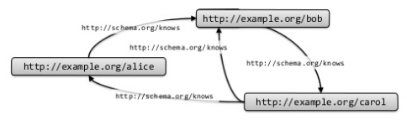
Write N-triple representation in proper format for the above graph.
1. Alice knows Bob
2. Bob knows Carol
3. Carol knows Alice
4. Carol knows bob

Part 2: (Marks = 3)
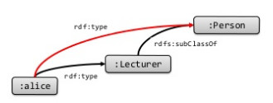
Write down RDFS inference with IF, AND, THEN clause.

IF: ___________________________________

AND:_________________________________

THEN:_________________________________

Part 3: (Marks = 6)
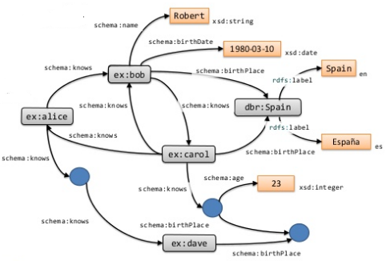
A. Write 5 Literal values.
1. _____________________________________
2._____________________________________
3. _____________________________________
4. _____________________________________
5._____________________________________
B. represents _________________________.
C. xsd:integer is __________________ in ______________________Language.

Part 4: (Marks = 5)
Consider the given graph to find reflexive and transition property for RDF with “abc” as PREFIX,

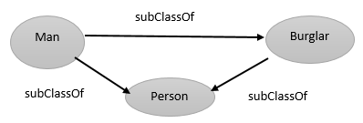

Reflexive property:
1. Man: ____________________________________________________
2. Burglar: ___________________________________________________
Transitive Property:
3. If __________________________________________________________
And __________________________________________________________
Then__________________________________________________________

Part 5. (Marks = 2)
1. What you can infer to get domain:

ts: hasFriend rdfs:domain ts:Person.
tsgroup:tim ts:hasFriend tsgroup:Clinp.

2. What you can infer to get range:

ts: hasFriend rdfs:range ts:Person.
tsgroup:tim ts:hasFriend tsgroup:Clinp.

THE END

Question 1: (Marks = 20)

Solve Multiple Choice Questions:

1. In RDF schema, variable names start with,
- !
- #
- ?
- @
Answer: c
2. In RDFS to use core class of all strings, the element used is
- rdfs:Literal
- rdfs:Class
- rdfs:Resource
- rdf:Statement
Answer: A
3. In RDFS to use core property of relationship among class and its superclass, the element used is
- rdfs:subClassOf
- rdfs:Class
- rdfs:subPropertyOf
- rdf:Property
Answer: A
4. RDF uses logical formula in
- Semantic Web
- Graph view
- XML view
- Definition view
Answer: D
5. In container element, the pre-defined type used for referencing other than first element of list is
- rdf:rest
- rdf:first
- rdf:List
- rdf:nil
Answer: A
6. In RDF Schema, the functional symbol returns true if a is a list is
- list(a)
- item(y,a)
- rest(a)
- first(a)
Answer: A
7. In RDF Schema, the functional symbol for returning the rest of the list is
- rest(a)
- first(a)
- cons(y,a)
- nil
Answer: A
8. __________ is framework for viewing, manipulating, and associating networked collections of distributed information.
- GRDDL
- RDFa
- RFDFS
- RDF
Answer: D
9. Edges and vertices are labeled with URIs. It has blank node identifier.
- Multi graph
- Directed graph
- Labeled graph
- Bi-directional graph
Answer: C
10. Resources described by RDF using tags ____________________.
- rdfs:Datatype
- rdfs:Resource
- rdfs:Class
- rdfs:Literal
Answer: B
11. _______________is an instance of rdf property that may be used to provide a human-readable description of a resource.
- rdfs:Resource
- rdfs:range
- rdfs:domain
- rdfs:comment
Answer: D
12. rdf:rest is an instance of rdf property that can be used to build descriptions of lists and other list-like structures.
- rdf:nil
- rdf:resource
- rdf:first
- rdf:rest
Answer: D
13. Triple (http://abc.html, dc:creator,_:abc), has _:abc, what does it means?
- Literal
- Blank nodes
- Namespace
- Unknown nodes
Answer: B
14. There are ____ ways of triple serialization in RDF.
- 1
- 4
- 2
- 3
Answer: C
15. If we want to replace rdf:li with some appropriate property in sequence, select the particular one.


- rdf:_last
- rdf:_front
- rdf:_1, rdf:_2, rdf:_3
- rdf:nil
Answer: C
16. In Rdfa use of Property tag is


- Add another resource
- Add another property
- Add another element
- Add another vocabulary
Answer: A
17. RDFa tag will be written in
- <HTML>
- <Title>
- <Body>
- <Head>
Answer: C
18. RDFa is perfectly well prepared to handle several vocabularies within one file. This is because RDFa is based on the usage of URIs, meaning that usage of various terms can be interleaved without any problems.
- True
- False
Answer: A
19. GRDDL processor execute each transformation collectively and perform an RDF merge on the generated graphs, yielding the result.
- True
- False
Answer: B
20. Which microformat will use to add details of student’s first_name, Last_name, address, Tel no. and CNIC no. etc.
- hCalender
- vCalender
- hCard
- vCard
Answer:D

Question 2: (Marks = 20)

Solve Short Questions:
Part 1: (Marks = 4)


Write N-triple representation in proper format for the above graph.
1. Alice knows Bob
2. Bob knows Carol
3. Carol knows Alice
4. Carol knows bob

Solution:
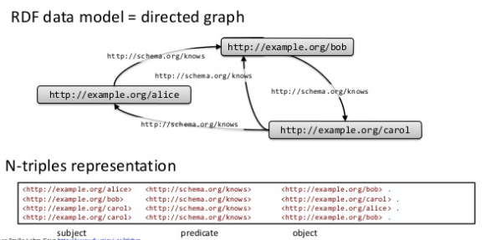

Part 2: (Marks = 3)

Write down RDFS inference with IF, AND, THEN clause.

IF: ___________________________________

AND:_________________________________

THEN:_________________________________

Solution:

IF: alice rdf:type Lecturer

AND: Lecturer rdfs:subClassOf Person

THEN: alice rdf:type Person

Part 3: (Marks = 6)

A. Write 5 Literal values.
1. _____________________________________
2._____________________________________
3. _____________________________________
4. _____________________________________
5._____________________________________
B. represents _________________________.
C. xsd:integer is __________________ in ______________________Language.

Solution:
A. 1. Robert
2. 1980-03-10
3. Spain
4. Espana
5. 23

B. blank nodes
C. datatype, XML

Part 4: (Marks = 5)
Consider the given graph to find reflexive and transition property for RDF with “abc” as PREFIX,



Reflexive property:
1. Man: ____________________________________________________
2. Burglar: ___________________________________________________
Transitive Property:
3. If __________________________________________________________
And __________________________________________________________
Then__________________________________________________________

Solution:
Reflexive property:
1. Man: abc:Man rdfs:subClassOf abc:Man
2. Burglar: abc:Burglar rdfs:subClassOf abc:Burglar
Transitive Property:
3. IF abc:Man rdfs:subClassOf abc:Person
And abc:Burglar rdfs:subClassOf abc:Person
Then abc:Man rdfs:subClassOf abc:Burglar

Part 5. (Marks = 2)
1. What you can infer to get domain:

ts: hasFriend rdfs:domain ts:Person.
tsgroup:tim ts:hasFriend tsgroup:Clinp.

2. What you can infer to get range:

ts: hasFriend rdfs:range ts:Person.
tsgroup:tim ts:hasFriend tsgroup:Clinp.

Solution:
1. What you can infer to get domain:
ts: hasFriend rdfs:domain ts:Person.
tsgroup:tim ts:hasFriend tsgroup:Clinp.
Answer:
tsgroup: tim rdf:type ts:Person.

2. What you can infer to get range:
ts: hasFriend rdfs:range ts:Person.
tsgroup:tim ts:hasFriend tsgroup:Clinp.
Answer:
tsgroup: tim rdf:type ts:Person.

THE END

